Bimetal thermometers qualified in accordance with both ASME and EN

Klingenberg, November 2018
WIKA has further developed its standard bimetal thermometers for global application in the process industry. The model TG53 conforms to the ASME B40.200 standard and is manufactured for the inch unit of measure. The model TG54 has been qualified in accordance with the EN 13190 standard.

The new thermometers are designed for flexibility in operation. Customers have a wide selection of nominal sizes and scale ranges available (between -70 °C/-94 °F and +600 °C/+1100 °F). The instruments have a high overtemperature resistance and are certified for low ambient temperatures down to -50 °C/-58 °F. With ATEX approval, IP65 ingress protection (optional up to IP68) and, in the version with liquid damping, they are also suitable for harsh operating conditions.

Both thermometer models are manufactured entirely from stainless steel. The instruments are available in back mount or lower back mount connection and adjustable stem and dial variants. The case has a dished anti-parallax dial which makes readability easier.

Number of characters: 1,014
Key word: TG53/TG54

Manufacturer:
WIKA Alexander Wiegand SE & Co. KG
Alexander-Wiegand-Straße 30
63911 Klingenberg/Germany
Tel. +49 9372 132-0
Fax +49 9372 132-406
vertrieb@wika.com
www.wika.de

WIKA company photograph:
Standard bimetal thermometers for global application in the process industry, model TG53 and model TG54

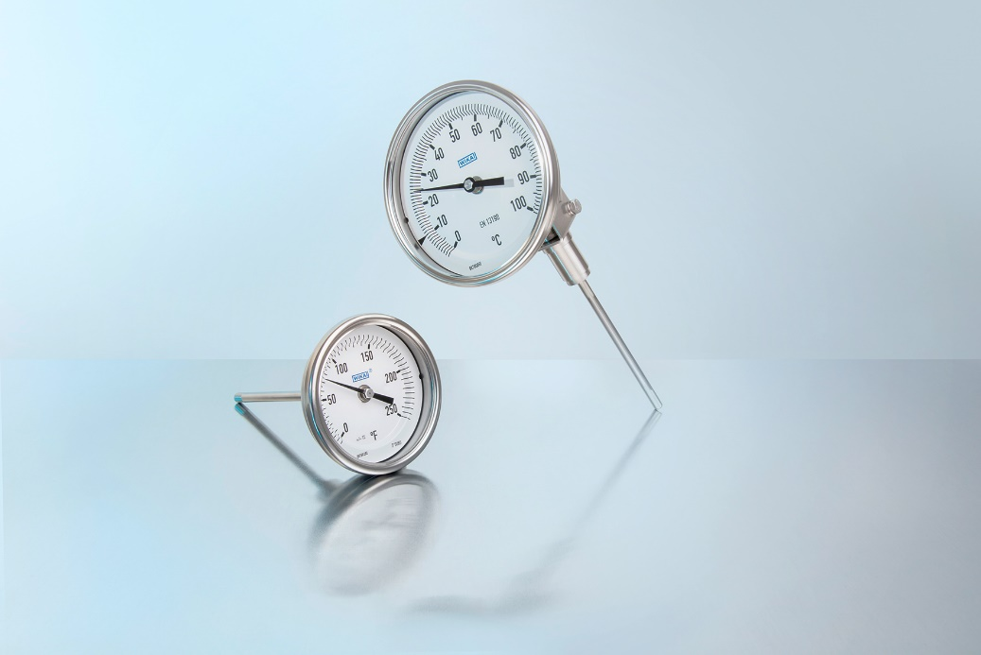

Edited by:
WIKA Alexander Wiegand SE & Co. KG
André Habel Nunes
Marketing Services
Alexander-Wiegand-Straße 30
63911 Klingenberg/Germany
Tel. +49 9372 132-8010
Fax +49 9372 132-8008010
andre.habel-nunes@wika.com
www.wika.de

WIKA press release 13/2018

