Reed level transmitter
suitable for food applications
Klingenberg, October 2020. WIKA has expanded its range of level transmitters with reed measuring chain by adding the model FLR-F for food applications. The instrument has an electropolished surface with a roughness of < 0.8 µm Ra and is available with application-specific process connections such as TriClamp.

The level transmitter works on the float principle with magnetic transmission. It measures the level reliably, even with foaming, and can additionally output a temperature value. The reed contacts in the guide tube (up to six metres long) can be arranged as a quasi-continuous level measurement.

The model FLR-F is also available in a version with a head-mounted transmitter for different output signals and communication protocols. Furthermore, the instrument can be supplied with a removable float limitation and FDA-compliant sealing or in an ATEX variant for applications in which pipes are cleaned with flammable media.

Number of characters: 906
Key word: FLR-F

Manufacturer:
WIKA Alexander Wiegand SE & Co. KG
Alexander-Wiegand-Straße 30
63911 Klingenberg/Germany
Tel. +49 9372 132-0
Fax +49 9372 132-406
vertrieb@wika.com
www.wika.de

WIKA company photograph:
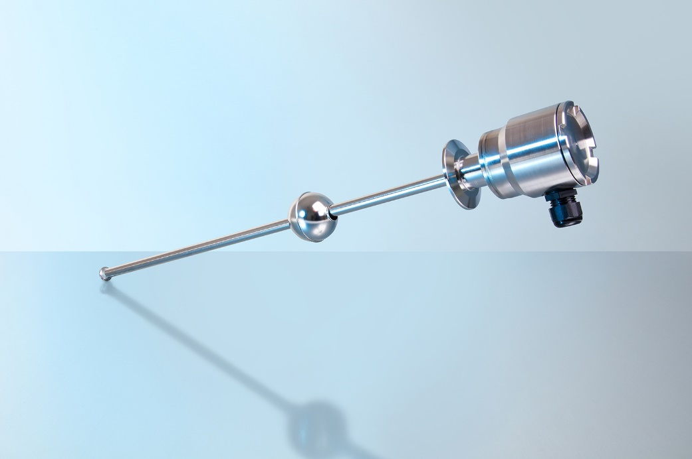
Typ: FLR-F

Edited by:
WIKA Alexander Wiegand SE & Co. KG
André Habel Nunes
Marketing Services
Alexander-Wiegand-Straße 30
63911 Klingenberg/Germany
Tel. +49 9372 132-8010
andre.habel-nunes@wika.com
www.wika.de

WIKA press release

