T32.xS temperature transmitter
with new HART® protocol

Klingenberg, July 2018.
The T32.xS temperature transmitter from WIKA is now also available in a version which communicates via the new HART® 7 protocol. Its new functions include, among others, an extended measuring point description (Long Tag).

All the other features of the instrument remain unchanged. TÜV Rheinland has once more certified the T32.xS in a full assessment for safety applications up to SIL 3. Due to its compatibility with almost all open software and hardware tools, the transmitter can be used universally. This successful instrument, of which more than one million pieces have already been delivered, is also still available in its previous version with HART® 5.

Number of characters: 661
Key word: T32.xS/HART® 7

Manufacturer:
WIKA Alexander Wiegand SE & Co. KG
Alexander-Wiegand-Straße 30
63911 Klingenberg/Germany
Tel. +49 9372 132-0
Fax +49 9372 132-406
vertrieb@wika.com
www.wika.de

WIKA company photograph:
T32.xS temperature transmitter with new HART® protocol

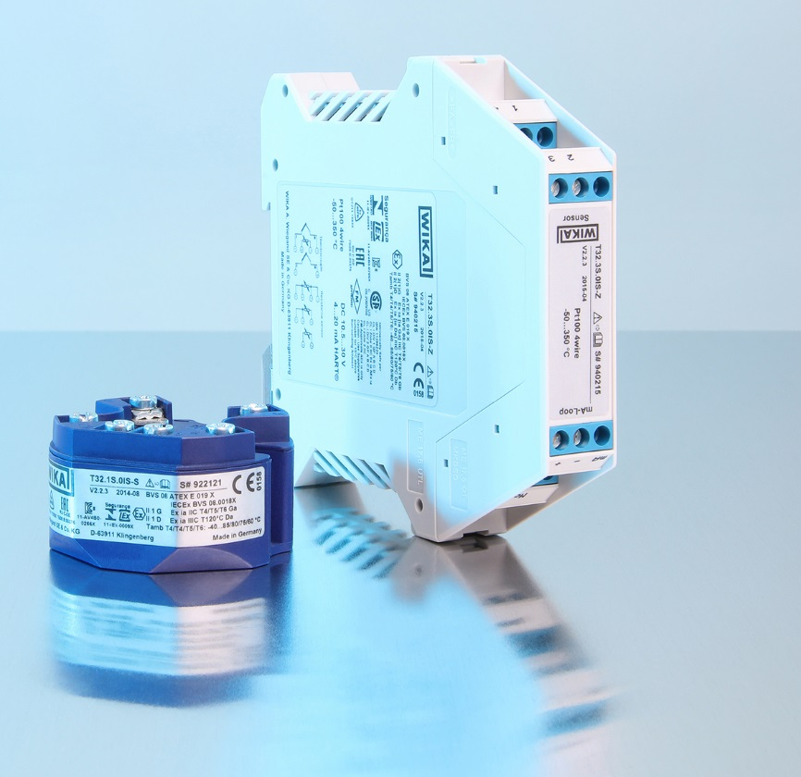

Edited by:
WIKA Alexander Wiegand SE & Co. KG
André Habel Nunes
Marketing Services
Alexander-Wiegand-Straße 30
63911 Klingenberg/Germany
Tel. +49 9372 132-8010
Fax +49 9372 132-8008010
andre.habel-nunes@wika.com
www.wika.de

WIKA press release 08/2018

