New precision digital pressure gauge with enhanced performance spectrum

Klingenberg, April 2016.
Extended measuring ranges, large data logger, wireless functionality and streamlined menu operation: With the model CPG1500, WIKA has launched an improved precision digital pressure gauge with an appealing price/performance ratio.

The new calibration and test instrument has been designed for versatile use. The CPG1500 covers pressure ranges up to 0 ... 1,000 bar and measures with an accuracy of up to 0.05 % of span. Its data logger can record up to 50 measured values per second. The data is transmitted wirelessly and can be processed using the WIKACal software. Further functionality, such as min/max memory or integrated temperature measurement, enhances the performance range.

The new menu structure of the CPG1500 enables a quicker intuitive input for all parameters. A 5½-digit display with bargraph and a large text field supports the analysis of measuring points on site.

The measuring quality of the CPG1500 is “packaged” within a robust design. As an intrinsically safe instrument (IECEx, ATEX, CSA approvals) and with IP65 ingress protection, it offers reliability and durability, even with extreme process conditions.

Number of characters: 1130
Key word: CPG1500

Manufacturer:
WIKA Alexander Wiegand SE & Co. KG
Alexander-Wiegand-Straße 30
63911 Klingenberg/Germany
Tel. +49 9372 132-0
Fax +49 9372 132-406
vertrieb@wika.com
www.wika.de

WIKA company photograph:
Precision digital pressure gauge model CPG1500

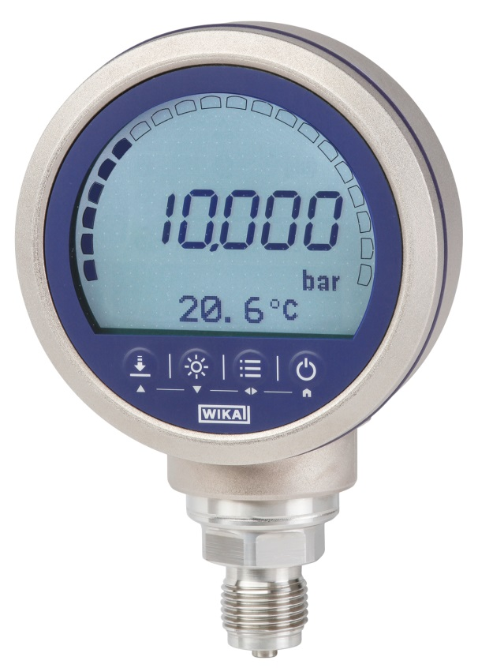

Edited by:
WIKA Alexander Wiegand SE & Co. KG
André Habel Nunes
Marketing Services
Alexander-Wiegand-Straße 30
63911 Klingenberg/Germany
Tel. +49 9372 132-8010
Fax +49 9372 132-8008010
andre.habel-nunes@wika.com
www.wika.de

WIKA press release 07/2016

