Configure and read instruments
via app and smartphone
Klingenberg, October 2016.
With the new CPG1500 precision digital pressure gauge from WIKA, customers can now also communicate with it via smartphone. The corresponding mobile app, “myWIKA device”, can be downloaded free of charge from the Google Play Store.

Via the app and the WIKA-Wireless connection, the CPG1500 can be conveniently configured for test and calibration tasks via mobile phone. During the pressure measurement, the measured value is shown on the display in the desired unit. Moreover, users can access further parameters such as temperature and pressure change rate and also additional instrument information via the WIKA website. The app also enables the configuration, control and storage of log operations. Since the app also communicates with the WIKA-Cal software, the logged data can be transmitted wirelessly for further processing on a suitable computer.

The new mobile app is currently available for smartphones with Android operating systems. For the time being, its functions relate only to the CPG1500 - however, versions for other WIKA calibration instruments are already planned.

Number of characters: 1084
Key words: “myWIKA device” app

Manufacturer:
WIKA Alexander Wiegand SE & Co. KG
Alexander-Wiegand-Straße 30
63911 Klingenberg/Germany
Tel. +49 9372 132-0
Fax +49 9372 132-406
vertrieb@wika.com
www.wika.de

WIKA company photograph:
With the new CPG1500 precision digital pressure gauge from WIKA, customers can now also communicate with it via smartphone using the “my WIKA device” mobile app.

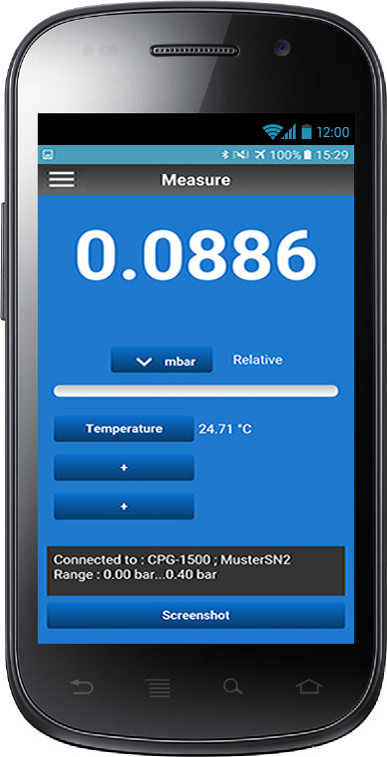

Edited by:
WIKA Alexander Wiegand SE & Co. KG
André Habel Nunes
Marketing Services
Alexander-Wiegand-Straße 30
63911 Klingenberg/Germany
Tel. +49 9372 132-8010
Fax +49 9372 132-8008010
andre.habel-nunes@wika.com
www.wika.de

WIKA press release 13/2016

